**Problem5**

**1.Description**

Get two images I1 and I2 of our campus and make sure that the major parts of I1 and I2 are from the same physical plane. Stitch I1 and I2 together to get a panorama view using scale-normalized LoG (or DoG) based interest point detector and SIFT descriptors. You can use OpenCV or Matlab. You are allowed tocall the build-in functions provided by Matlab or OpenCV.

**2.Procedure**

SIFT is an algorithm used for image feature detection and description, with scale invariance and rotation invariance. It detects key points in the image by constructing a Gaussian difference pyramid, extracts unique local features, and generates descriptors to match the images under different perspectives, illumination and other conditions.

Basic steps of SIFT:

**·Building the Gauss Pyramid**

Gaussian blur of different scales is performed to generate Gaussian pyramids, aiming to obtain the scale invariance of feature points through image analysis at different scales.

**·Gaussian difference (DoG) calculation**

On the basis of the Gaussian pyramid, the Gaussian difference map (DoG) of the adjacent layers is calculated to detect the key point position in the image. This step locates the potential key points by finding the local extreme value points.

**·Key point positioning and precision**

Further accurately locate the detected extreme value points, and eliminate the key points with low contrast or the points with unstable edges, to ensure the stability of the key points.

**·Direction distribution**

Assign one or more directions to each key point, according to the gradient direction histogram near the key point (to ensure the invariance of the key point in the image rotation.

**·Feature descriptor generation**

Then, a descriptor with rotation invariance (128-dimensional vector) is generated based on the image gradient information around the key point. The descriptor describes the texture information of the local area of the image and is able to play a key role in the matching.

**·Key Match**

Descriptors in two images were matched using Euclidean distance or other matching algorithms, usually screened with nearest neighbor and Lowe's Ratio Test, retaining the best matching pairs.

The following is the whole process of this image stitching process:

We input the two raw images as follows:

Problem5\image\input\left.png:

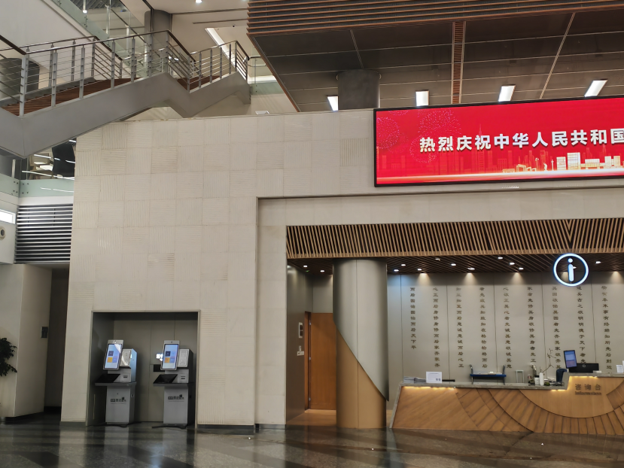

Problem5\image\input\right.png:

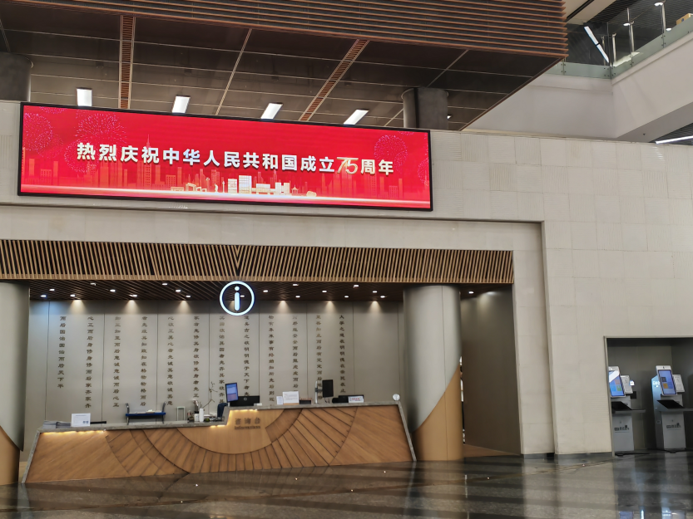

**·Key point detection and descriptor calculation**

Key point descriptor detection and calculation of the input image using the detectKeypointsAndDescriptors function:

# 使用SIFT检测关键点并计算描述符

def detectKeypointsAndDescriptors(img):

    # 先将图像转换为灰度

gray = cv2.cvtColor(img, cv2.COLOR_BGR2GRAY)

    # 调库使用SIFT算法检测关键点和计算描述符

    sift = cv2.SIFT_create()

    # 检测关键点并计算描述符，detectAndCompute 函数中自带 DoG

    keypoints, descriptors = sift.detectAndCompute(gray, None)

    return keypoints, descriptors

Images were first converted to gray scale. The cv2.SIFT_create() function was called to generate the SIFT detector. Use the detectAndCompute method to automatically detect the key points of the image and calculate the corresponding descriptors, equipped with a key point detector based on the DoG.

The two images generated are as follows:

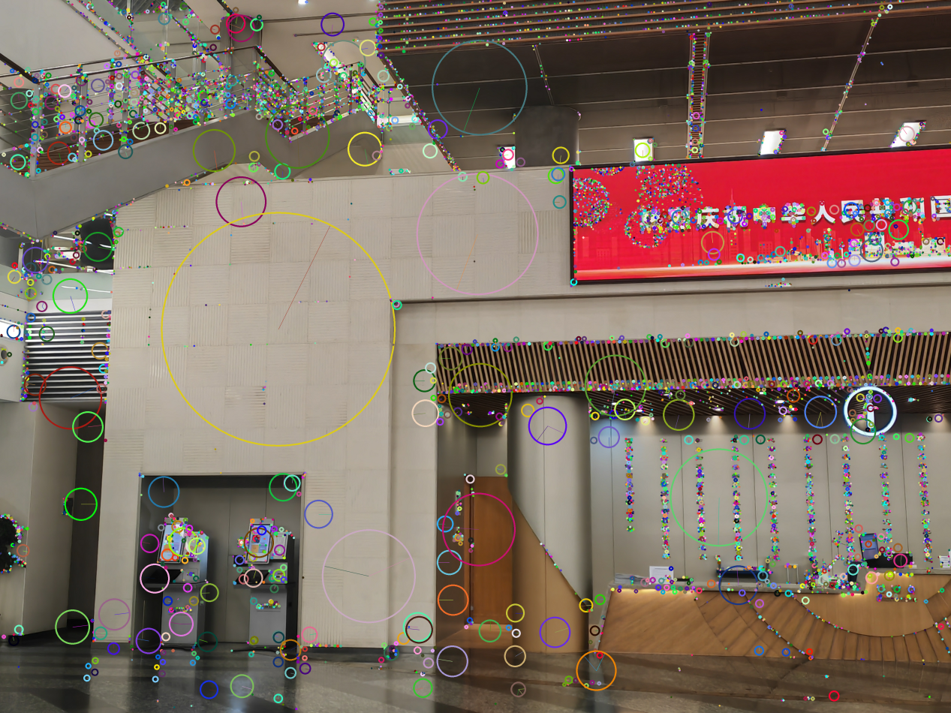Problem5\image\output\originKeypointsLeft.png:

Problem5\image\output\originKeypointsRight.png:

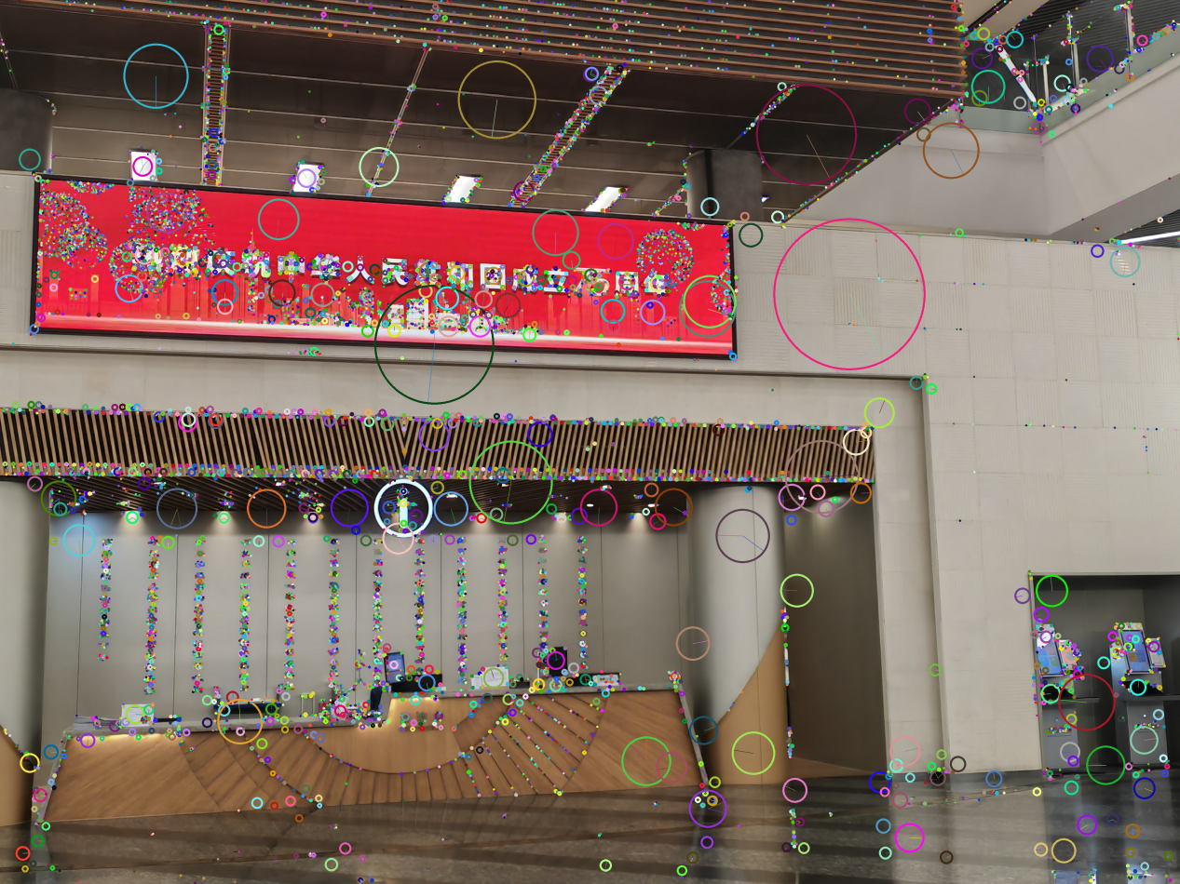**·FLANN Matcher to match the key points and Lowe's Ratio Test to filter matching points**

As we can see from the above two figures, there are many key points. But we found that not all key points have matches, and we need to make the matches more accurate. So we chose Lowe's Ratio Test.Also we used the FLANN Matcher to match the key points.

The core idea of Lowe's Ratio Test is that in a nearest-neighbor match for each descriptor, a good match should be significantly better than the other. By comparing the distance differences between the two nearest-neighbor matches, those match pairs with little differences were filtered out and only those matches with significant differences were retained.

# 使用FLANN匹配器进行关键点匹配，并应用Lowe's Ratio Test筛选出好的匹配点

def matchKeypoints(des1, des2, kp1, kp2):

    # FLANN 匹配器参数

    FLANN_INDEX_KDTREE = 1

    indexParams = dict(algorithm=FLANN_INDEX_KDTREE, trees=5)

    searchParams = dict(checks=50)

    # 创建 FLANN 匹配器

    flann = cv2.FlannBasedMatcher(indexParams, searchParams)

    # 执行 KNN 匹配

matches = flann.knnMatch(des1, des2, k=2)

    # 使用Lowe's Ratio Test筛选匹配点

    goodMatches = []

    for m, n in matches:

        if m.distance < 0.7 * n.distance:

            goodMatches.append(m)

    return goodMatches

The FLANN Matcher is used to match the key points of the image. First, the FLANN Matcher is created by setting the index and search parameters of the KD-Tree algorithm, and then the KNN matches to find the two nearest neighbor matches for each feature point. Next, Lowe's Ratio Test was applied to select eligible "good" matches by comparing the distances between the two neighboring points to improve matching accuracy and reduce mismatches.

The set of matched points for the following two graphs:

Problem5\image\output\filteredKeypointsLeft.png

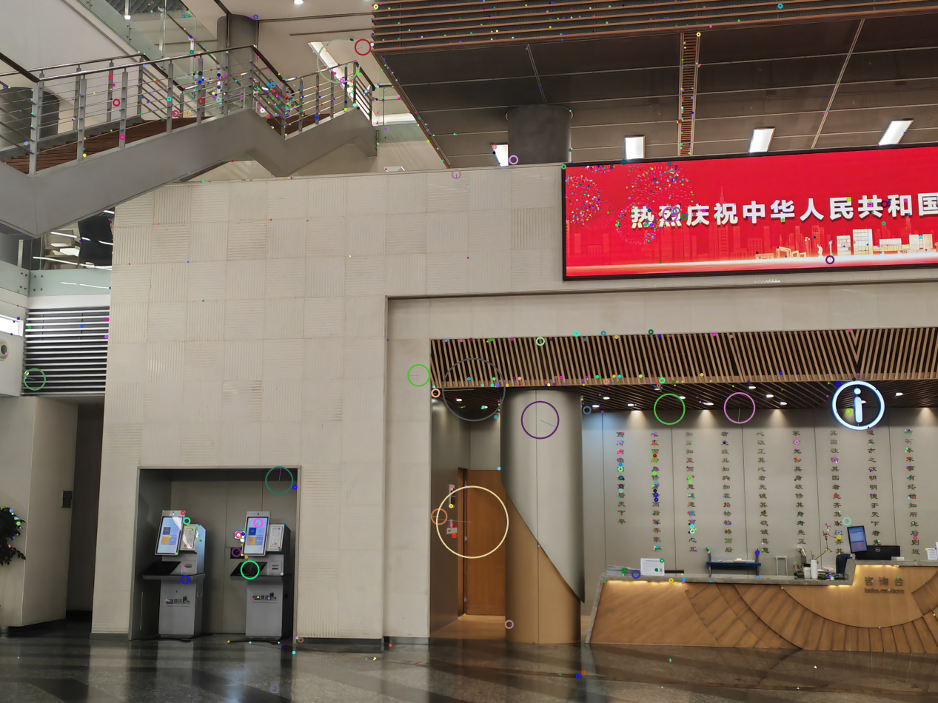

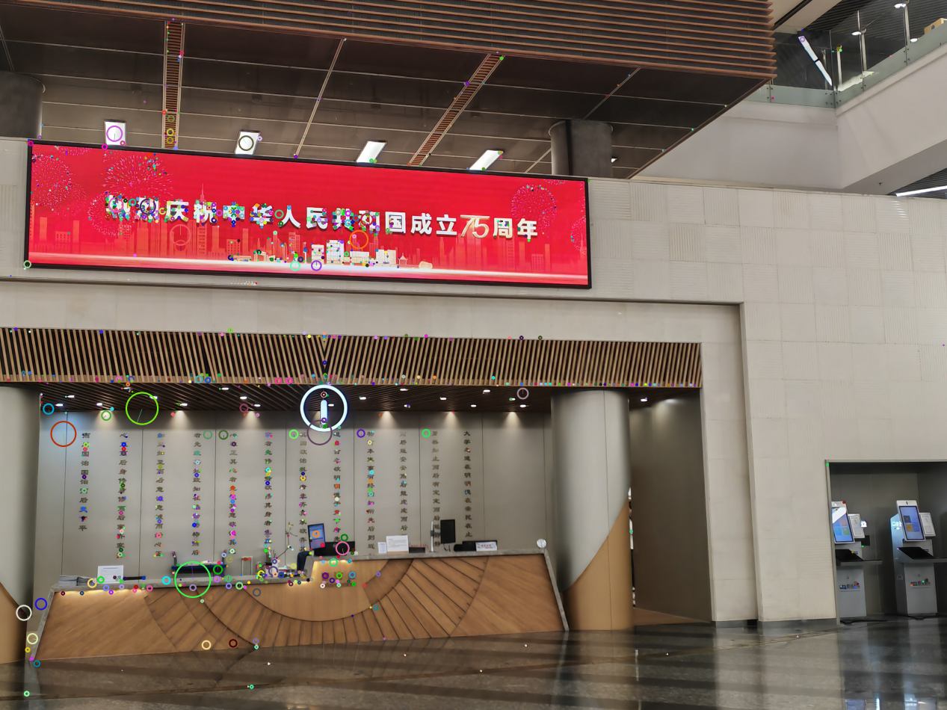Problem5\image\output\filteredKeypointsRight.png

The key points for matching the two images are as follows:

Problem5\image\output\keypointMatches.png

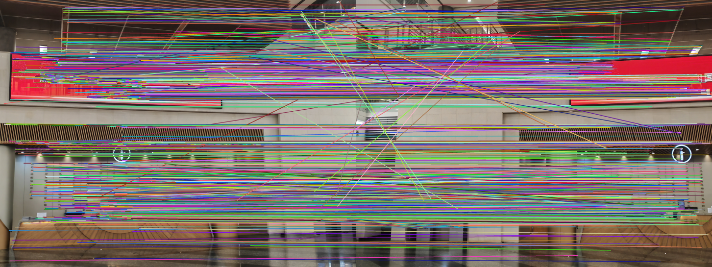**·Splice using matched keypoints**

Using the matched key points, the two images were perspective-transformed by calculating the single response matrix, and then the two images were stitched together using the RANSAC algorithm.

# 使用匹配的关键点对两幅图像进行拼接

def stitchImages(img1, img2, kp1, kp2, goodMatches):

    # 提取匹配点的坐标

    points1 = np.float32([kp1[m.queryIdx].pt for m in goodMatches]).reshape(-1, 1, 2)

points2 = np.float32([kp2[m.trainIdx].pt for m in goodMatches]).reshape(-1, 1, 2)

    # 检查匹配点数量是否足够

    if len(points1) < 4 or len(points2) < 4:

        raise ValueError("Not enough good matches after filtering.")

# 调库使用RANSAC算法计算单应矩阵

    H, mask = cv2.findHomography(points1, points2, cv2.RANSAC, 5.0)

    h, w, _ = img2.shape

# 将第一张图像变换到第二张图像的视角

    panorama = cv2.warpPerspective(img1, H, (w*2, h))

    panorama[0:h, 0:w] = img2

    return panorama

The keypoint coordinates of the two images were extracted from the filtered "good" matching points and converted to a floating-point NumPy array. Next, check whether the number of these matching points is sufficient for four. Then, using the cv2.findHomography function in OpenCV, combined with the RANSAC algorithm to calculate the monoresponse matrix between two images, which is used to transform the perspective of one image to another image. Then, using the cv2.warpPerspective function, the first image was perspective-transformed according to the single-response matrix to align it with the second image. Finally, the two images are stitched together.

**3.Result**

Through the matching key points, the single response matrix is calculated to transform the two images through perspective. Specifically, the feature points in the two images are first extracted and matched, and then the monoresponse matrix is calculated using these matching points, ensuring that the two images are aligned to the same perspective. Next, the RANSAC algorithm is used to optimize these matches and get a more accurate transformation matrix. Finally, the matrix is used to visually transform two images and stitch them together to generate a seamless synthetic image.

# 使用SIFT和FLANN匹配器从两幅图像创建全景图

def createPanorama(imagePath1, imagePath2):

    img1 = cv2.imread(imagePath1)

    img2 = cv2.imread(imagePath2)

# 检测两幅图像中的关键点和描述符

    kp1, des1 = detectKeypointsAndDescriptors(img1)

    kp2, des2 = detectKeypointsAndDescriptors(img2)

# 匹配两幅图像之间的关键点

    goodMatches = matchKeypoints(des1, des2, kp1, kp2)

# 使用匹配的关键点拼接图像

    panorama = stitchImages(img1, img2, kp1, kp2, goodMatches)

    return img1, img2, kp1, kp2, goodMatches, panorama

The final spliced images are as follows:

Problem5\image\output\panoramaResult.png

The final splicing effect is still very accurate. At this point, the task of obtaining a panoramic view was accomplished satisfactorily using the point-of-interest LoG (or DoG detector and SIFT descriptors based on proportional normalization).